Water-cooled angle parallel shaft geared motors of WATT and WEG

Drives installed in steel plants have to defy hardest environmental conditions. The water-cooled drives designed by WATT have been especially developed for the demanding environment of the steel industry. In combination with a WEG roller table motor, a reliable and efficient drive is created.

Steel production demands most reliable products resulting from the high investment costs of such machinery.
The main task of the roller table drives is to accelerate and decelerate the slabs on the machinery. Owed to extreme environmental temperatures in combination with high acceleration torque, the special gears have been designed with an integrated water jacket and a spheroidal graphite iron housing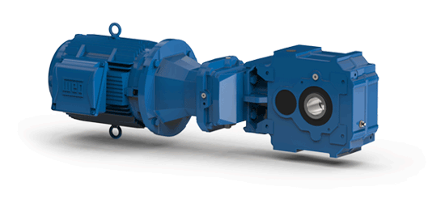
Pict. 1: WATT angle parallel shaft gearbox with WEG roller table motor

Technical specialties of the gears:

- Spheroidal graphite iron housing EN-GJS-400-15
- Integrated water jacket
- Sealing with Viton seal rings on hardened running surfaces as well as a labyrinth seal on the output
side
- Heat protection shield
- Torque support directly at the gear housing
- Synthetic lubricant
- WEG Roller table motor

The use of qualitatively high drive technique ensures low maintenance- and service costs.

WATT steelwork gears:

The drives are available in various variants:

- Helical-, bevel- and parallel shaft gear
- Output torque from 1,250 up to 20,000Nm
- Torque range and gear reduction from the MAS® gear system
- In the course of drive selection, the gear will be chosen together with the customer, according to the particular thermal environmental influences.

Gear characteristics:

- Type: CWA 81A (GJS) IAK160
- Motor power: 4kW (500V, 50Hz)
- Output speed: 30rpm
- Gear rated torque: 2,700Nm

WEG Special motors:

The ample and worldwide available motor programme of WEG allows a project-oriented supply of numerous mechanical and electrical options.
The motors can be assembled as circular finned motors of spheroidal cast iron or as unventilated grey cast iron motors. It either can be mounted with a motor adapter or directly, which would increase the efficiency.

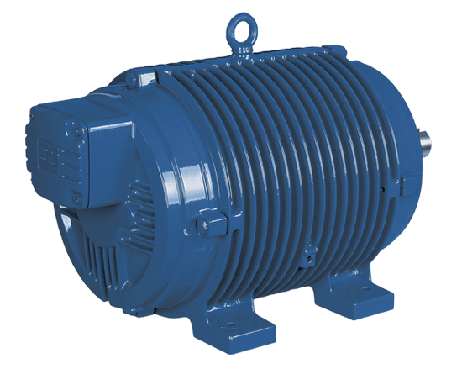
Pict. 2: WEG roller table motor

Further information about WEG roller table motors can be found under the following link:
http://www.weg.net/at/Produkte-Services/Electric-Motors/IEC-General-Purpose/Roller-Table

