WATT MAS Drives for Spiral Pipe Manufacturing

Watt Drive delivered the entire drive technique for a large-diameter pipe plant. The drives are used for the pipe transport system, the welding stands and the turning devices.

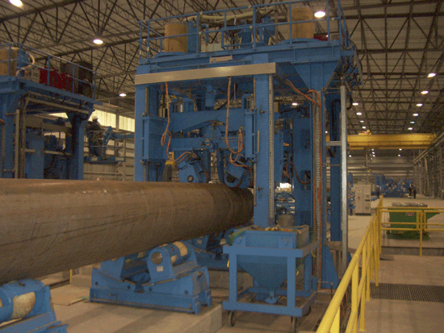

Picture 1: Spiral Pipe Manufacturing

Machinery description

The project was realised by the company DANIELI W+K Industrie Technik GmbH & Co. KG from Dortmund.
Hot rolled strip in the coil is used as base material for the manufacturing of spiral pipes. It is formed into a spiral-formed pipe body and directly after that welded ready with the submerged arc welding technique. This technique is used for the inner- and outer seam and is performed simultaneously.

Transport systems

Pipes with a diameter of 508mm (20“) up to 2540mm (100“) are conveyed with the transport system (see picture 2). The hugest pipe with a length of 18m thereby weighs 27 tons. The maximum conveying speed is 30m/min and is kept constant at all pipe diameters with geared motors that are energised by frequency inverters.

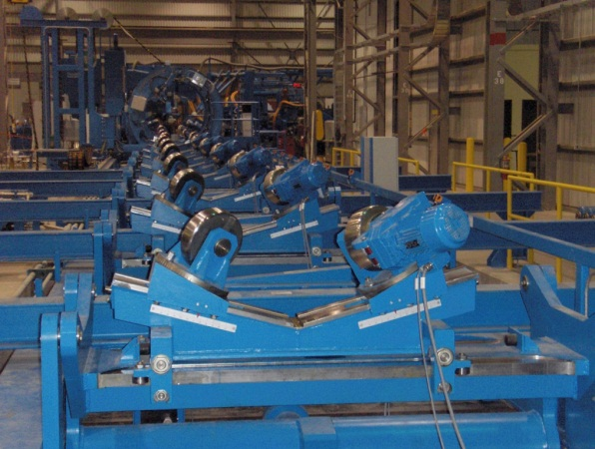

Picture 2: Pipe transport system after shaping

Implemented drives: 223 shaft mounted geared motors ASA 66A 81N4 TH

- Motor power: 0.75kW
- Output speed n₂: 15U/min
- Output torque M₂: 481Nm
- Service factor: 1.7

Drive concept

In the range of 5 - 50Hz the drives are run with a constant torque, in the range of 50 – 110Hz with field weakening (constant power).
Huge pipe diameter– high weight with the need of high torque – at low speed.
Small pipe diameter – low weight with the need of low torque – at high speed.

Turning devices

Drives with brakes are implemented for the turning devices (see picture 3). This enables a precise and step-by-step quality check of the spiral pipes. The pipes are examined by visual or x-ray check.

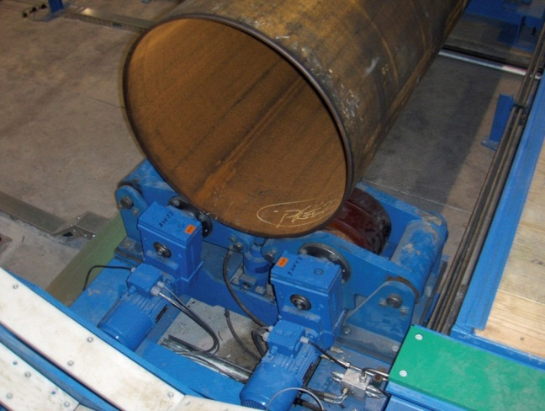

Picture 3: Turning device for quality checking the pipes

Implemented drives: 52 shaft mounted geared motors ASA 66A 81N4 BR5 TH

- Motor power: 0.75kW
- Output speed n₂: 12U/min
- Output torque M₂: 577Nm
- Service factor: 1.4

