WEG announces acquisition of German electric motors and geared motors manufacturer
WEG S.A. (Bovespa: WEGE3 / OTC: WEGZY) announced that it has agreed to acquire the electric motors and geared motors manufacturer Württembergische Elektromotoren GmbH. The acquisition is subject to customary conditions and approvals by regulatory agencies.
Württembergische Elektromotoren GmbH is a family owned business founded in 1939, and with manufacturing plants located in Balingen, south central Germany, 75 km from Stuttgart, one of the most industrialized regions of the country. The company offers gearboxes, three phase and single-phase electric motors, direct current electric motors up to 1,000 watts and fractional servomotors. The manufacturing plant occupies an area of 5,000 square meters, employing around 80 people. Net revenues in 2013 were of approximately € 7 million.
Mr. Siegfried Kreutzfeld, WEG Motors’ Managing Director, said that the acquisition is attractive for two reasons. “We can now offer a more complete line of gearboxes in the European market, a segment in which we began to operate since the acquisition of Watt Drive, in 2011” says the executive. “In addition, we get access to a very interesting clients base right in Europe’s industrial heartland”.

Caption:
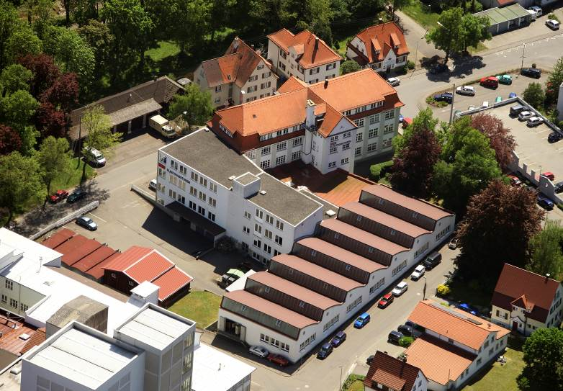
WEG2180_Bild1: WEG acquires Württembergische Elektromotoren GmbH. The picture shows the latter’s production plant in Balingen; Germany.

About WEG

WEG is a major global player in the power distribution, automation and control sector. The company’s global sales now exceed US $3-billion, representing increasing global success across a wide range of product groups. These include the latest generation of transformers, LV control gear, generators, gear motors, inverter drive systems, soft starters, LV/MV and HV motors, ATEX- compliant explosion proof motors, smoke extraction motors and full turnkey systems.

Editor Contact
Ian Clay, Technical Publicity
Tel: +44 (0)1582 390980 Mob: +44 7768 827009
Email: iclay@technical-group.com

Company Contact
Marek Lukaszczyk, WEG Electric Motors (UK) Ltd
Tel: +44(0)1527 513800 Fax: +44(0)1527 513810
Web: www.weg.net
Email: wegsales@wegelectricmotors.co.uk

