WEG launches new European automation centre
Drive technology specialist WEG has combined its automation expertise and resources and opened a new automation centre at its site in Unna, Germany.
WEG, a leading international supplier of drive technology, has opened a new European automation centre to improve support for its customers and to further strengthen its automation components business in Europe. In addition to locating its European automation specialists in the new centre, WEG is opening a shop with test stands, a training centre and warehouse space for automation components.

With the main objective of concentrating forces in one location to boost awareness of WEG's frequency inverters, soft starters and servo drives in Europe, the new centre will be led by both Fábio Gonçalez, the recently appointed EME Automation Manager and head of the Automation Centre, and Bernd Kaiser, Automation and Drive Systems Manager at WEG Germany. The company is also recruiting new employees for the expanded premises and relocating experts from other sites to Unna.

The opening of the new automation centre brings together WEG’s staff and its expertise from the German headquarters in Kerpen with those of its subsidiary Watt Drive to a single location. This leads to an even closer integration of Watt Drive gear technology, particularly technology for relatively low power levels, with automation components such as frequency inverters.

The in-house training centre for automation topics and the dedicated test stands in the shop enable WEG to better respond to customer needs and increase customer awareness of WEG's automation portfolio. Now frequency inverters, soft starters and servo drives for example, can be set up, repaired and modified with custom software at the centre in Unna. The experts can also look after the layout of complete electrical cabinets.

“In the last few years we have constantly expanded and optimised our sales organisation in Germany,” says Klaus Sirrenberg, Director Low Voltage Products at WEG Germany. “Establishing the automation centre is a strategic move to increase customer awareness of our automation portfolio in Europe. In Brazil we are the market leader in automation, but in Europe we are presently primarily known as a manufacturer of electric motors. Our goal is to be regarded as a solution provider, and the new automation expertise centre enables us to get even closer to our customers and offer them improved support. I think we're heading in right direction.”

To create room for the automation centre, WEG has expanded its premises at the Watt Drive site in Unna to cover several floors and now occupies the entire office building. This move also provides space for further growth in the sales and service functions. In addition, WEG is leasing more warehouse space to handle its growing European portfolio of automation products.

Contact: WEG Automation Center
Watt Drive GmbH
Heinrich-Hertz-Straße 14
59423 Unna, Germany
Phone: +49 (0)2303-9868-70
E-mail: wg-automation@weg.net

Figure caption:
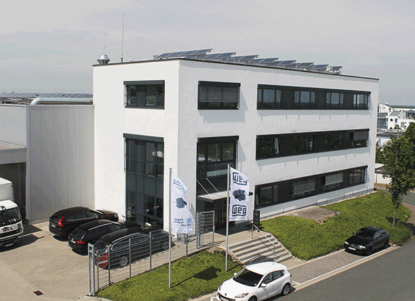
WEG2242_Picture 1: The new automation centre in Unna is the focal point of WEG's automation expertise in Europe

About WEG

WEG is a major global player in the power distribution, automation and control sector. The company’s global sales now exceed US $3-billion, representing increasing global success across a wide range of product groups. These include the latest generation of transformers, LV control gear, generators, gear motors, inverter drive systems, soft starters, LV/MV and HV motors, ATEX- compliant explosion proof motors, smoke extraction motors and full turnkey systems.
Editor Contact
Julia Swan, Technical Publicity
Tel: +44 (0)1582 390980
Email: jswan@technical-group.com

Company Contact
Marek Lukaszczyk, WEG Electric Motors (UK) Ltd
Tel: +44(0)1527 513800 Fax: +44(0)1527 513810
Web: www.weg.net
Email: wegsales@wegelectricmotors.co.uk

