New frequency inverter for decentralised motor and wall installation
WEG, a global leading supplier in drive technology, has launched the MW500 robust frequency inverter with decentralised design that simplifies commissioning, installation and motor start-up. The high performance drive is a space-saving solution that can be mounted directly on motor terminal boxes without any special protective housing, or adjacent to the motor on the wall. As a result, the need for lengthy cables and switch cabinets is eliminated, which reduces installation costs, and it provides high flexibility of the installation.

MW500 is robust with an IP66 protection rating. It can withstand high overloading of 150% for 60 seconds every 10 minutes, and operate in temperatures up to 40°C (wall installation) and 50°C (motor installation). With increased ruggedness compared to alternative technologies, it provides reliable operation over a long service life.

The drive is also easy to maintain. Three LEDs on the top of the inverter indicate the state (ready, alarm and fault) of the motor so users can identify at quick glance the performance of the equipment. Furthermore, an optional line disconnector can be fitted for simple and safe maintenance.

The inverter is designed to operate asynchronous motors in the power range 0.75 to 7.5 kW, and is offered as three variants for a mains voltage of 380 to 400V (A: 1.1 to 1.5 kW, B: 2.2 - 4 kW and C: 5.5 - 7.5 kW), and for 200 to 240V, as variant A (0.75 to 1.1 kW). It is ideal for many applications, including centrifugal pumps and compressors in processing industries, ventilators and fans, mixer and filling machines, washing machines and driers, conveyor belts and mechanical engineering in general.

“Engineers are increasingly specifying variable speed drives to control their motors and make energy savings, however, many are limited in where they have to position the drive,” says Marek Lukaszczyk, European Marketing Manager at WEG. “With the MW500 engineers now have a flexible variable speed drive that can be set up exactly where required.”

The drive is available with a built-in analogue potentiometer to regulate the speed of an asynchronous motor without the need for a control panel. However, users can use the device simply and intuitively from an optionally integrated control panel (HMI), which is also available with remote control. The standard version of the MW500 has a PID process controller and an integrated PLC with numerous programming functions. An EMC filter conforming to EN 61800-3 is integrated in the device and category C2 and C3 variants are optional.

The decentralised inverter is based on the same successful device platform as WEG’s CFW500 frequency inverter. The MW500 is able to detect and enable simple, plug-and-play add-on components, and to guarantee maximum flexibility, digital inputs, outputs and communication protocols such as CANopen, DeviceNet and Profibus-DP are available as expansion modules. In addition, a mobile memory card, the Mcard, enables process data to be transferred easily from one device to another. The expansion modules and compatibility with frequency inverters in the CFW family (CFW500, CFW700 and CFW11) enable one device to address many different applications. As such, users require less stock and so save on both space and storage costs.

The Windows-based SuperdriveG2 application software for the programming, control and monitoring of the MW500 is available to download on the WEG website for free. For more information on WEG’s new MW500 and its range of drives visit www.weg.net.

Figure captions:
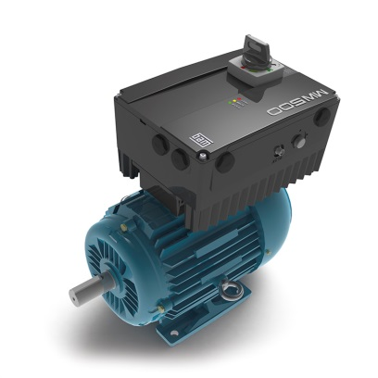
WEG2110_Figure 1: The decentrally designed MW500 frequency inverter can be fitted directly on the motor terminal box

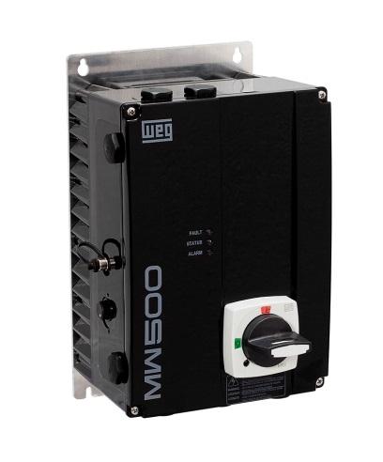
WEG2110_Figure 2: Its particular robustness means the MW500 can also be attached directly to the wall without a protective housing

About WEG

WEG is a major global player in drive technology as well as in the power distribution, automation and control sector. The company’s global sales now exceed US $3-billion, representing increasing global success across a wide range of product groups. These include the latest generation of transformers, LV control gear, generators, gear motors, inverter drive systems, soft starters, LV/MV and HV motors, ATEX- compliant explosion proof motors, smoke extraction motors and full turnkey systems.

Editor Contact
Marco Giudici, Technical Publicity
Tel: +44 (0)1582 390991
Email: mgiudici@technical-group.com

Company Contact
Marek Lukaszczyk, WEG Electric Motors (UK) Ltd
Tel: +44(0)1527 513800 Fax: +44(0)1527 513810
Web: www.weg.net
Email: wegsales@wegelectricmotors.co.uk

