**System solutions made in Europe**

***In Portugal, WEG produces high-performance drive systems for low-voltage and medium-voltage operation as package solutions integrated into electrical cabinets.***

WEG, a leading worldwide vendor of drive technology, presented integrated variable speed drive systems for low voltage and medium voltage operation from European production at this year’s edition of SPS IPC Drives. The MVW3000 series of modular variable speed drives for voltages from 2.3 kV to 8 kV and power levels from 280 kW to 2400 kW are produced entirely in Portugal. A special feature of these variable speed drives is that they are offered as package systems integrated into an electrical cabinet, consisting of an isolating switch, protective devices, multi-level feed transformer and frequency inverter. They can be combined with WEG low voltage and medium voltage motors to form efficient drive solutions. The nearly sinusoidal output voltage of the variable speed drive systems also makes them suitable for retrofit projects.

“As a drive technology manufacturer with a worldwide presence, WEG has been producing integrated automation and switchgear cabinet systems for a long time already, and now we are also producing them in Europe. By manufacturing industrial drive systems in Portugal, we strengthen our position in the European market. Production in Europe has important advantages for us: the manufactured drive and automation systems inherently fulfil all European standards, and we achieve even faster delivery times for application-specific system solutions. Customer acceptances with European companies can also be carried out significantly faster and easier”, explains Johannes Schwenger, Head of Product Management Europe for Low and Medium Voltage Drive Systems at WEG.

The MVW3000 device family is designed with multilevel technology using cascaded H bridges (CHB). That makes it possible to achieve voltage levels in the medium voltage range using proven standard low voltage components (diodes, IGBTs and plastic film capacitors) in a cost-effective manner. The efficiency of the variable speed drives, including the transformer, is 95% over the entire speed setting range. Furthermore, in the interest of enhanced reliability and system availability, the MVW3000 is equipped with motor protection devices for overload, overheating and motor rotor blockage. The temperatures of the power stage and transformer are also constantly monitored.

“The MVW3000 is a high-performance all-in-one solution that eliminates the need for additional medium voltage switchgear”, says Johannes Schwenger. The variable speed drive system features very low harmonic distortion at the input, and its nearly sinusoidal output voltage reduces motor stress in operation. In addition, it offers high energy efficiency and availability as well as easy maintenance and a modular architecture.”

As a package system, the MVW3000 simplifies installation and commissioning. The plug-in power stages facilitate easy maintenance and fast replacement. With dimensions of 3,900 x 2,210 x 1,100 mm (W x H x D), the variable speed drive system has a small footprint. Furthermore, it can optionally be equipped with all commonly used industrial communication protocols, including Modbus, Profibus, Devicenet and Ethernet.

**WEG at SPS IPC Drives 2018: Hall 3A, Stand 466**

Follow WEG on  [Description: Description: Description: Description: Description: Description: Description: Description: Description: Description: Description: Description: Description: Description: Description: Description: Description: Description: Description: Description: Description: Description: Description: Description: Description: Description: Description: Description: Description: Description: Description: Description: Description: Description: Description: Description: Description: Description: Description: Description: Description: Description: Description: Description: Description: Description: Description: Description: Description: cid:image009.jpg@01CE8155.D3CFD760](http://www.twitter.com/WEG_Europe)   [Description: Description: Description: Description: Description: Description: Description: Description: Description: Description: Description: Description: Description: Description: Description: Description: Description: Description: Description: Description: Description: Description: Description: Description: Description: Description: Description: Description: Description: Description: Description: Description: Description: Description: Description: Description: Description: Description: Description: Description: Description: Description: Description: Description: Description: Description: Description: Description: Description: cid:image011.jpg@01CE8155.D3CFD760](https://plus.google.com/103642553426782648112)  [Description: Description: Description: Description: Description: Description: Description: Description: Description: Description: Description: Description: Description: Description: Description: Description: Description: Description: Description: Description: Description: Description: Description: Description: Description: Description: Description: Description: Description: Description: Description: Description: Description: Description: Description: Description: Description: Description: Description: Description: Description: Description: Description: Description: Description: Description: Description: Description: Description: cid:image010.jpg@01CE8155.D3CFD760](http://www.linkedin.com/company/weg-europe)

**Figure caption**

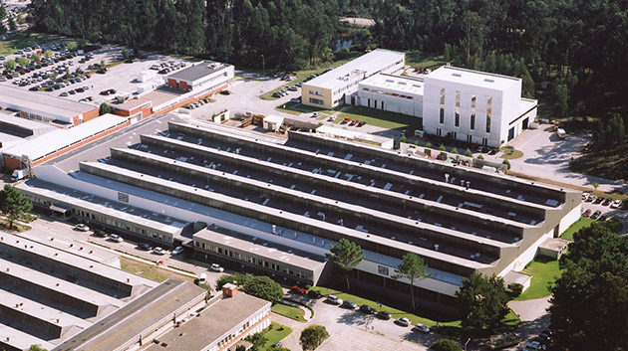

**WEG001557_Image1:** In the Maia plant in Portugal, WEG produces drive systems consisting of motors and variable speed drives as package solutions for low voltage and medium voltage operation

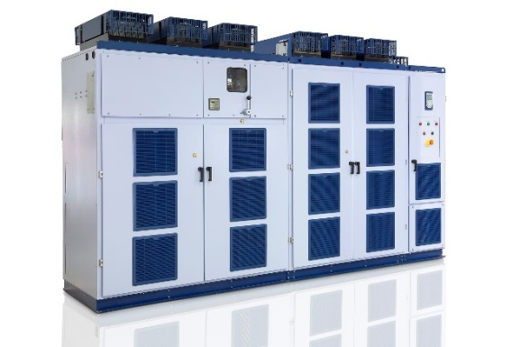

**WEG001557_Image2:** The MVW3000 variable speed drive is designed as a complete system for fast, easy installation and commissioning

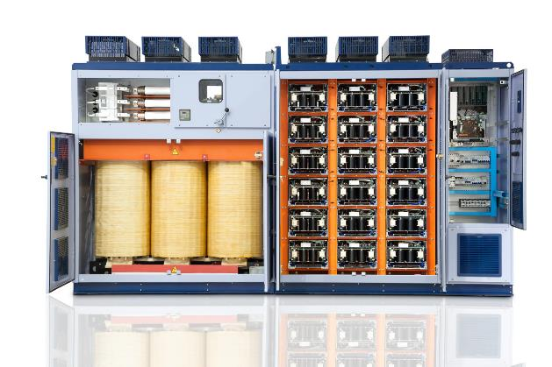

**WEG001557_Image3:** The MVW3000 is supplied as a complete system integrated into an electrical enclosure, including medium voltage isolator, protective devices, multilevel feed transformer and frequency inverter

## About WEG

WEG is one of the largest global manufacturers of electric equipment, having five main Business Units: Motors, Energy, Transmission and Distribution, Automation and Coatings.  The company employs over 30,000 people worldwide and in 2017 achieved global sales of R$ 9.5 billion, representing success across a wide range of product groups.  These include the latest generation of transformers, LV control gear, generators, gear motors, inverter drive systems, soft starters, LV/MV and HV motors, ATEX-compliant explosion proof motors, smoke extraction motors and full turnkey systems.

Its power generation, transmission and distribution solutions enable those across many industries, especially in the oil & gas, water, power distribution, chemical and petrochemical markets, to operate more efficiently, and to reduce energy usage, carbon emissions and environmental impact. In addition, WEG provides full solutions for renewable energy projects, producing complete wind turbine and solar energy systems.

**Editorial Contact**

Ian Jarrett, Publitek  
Tel: +44 (0)1582 390980   
Email: [ian.jarrett@publitek.com](mailto:ian.jarrett@publitek.com)

**Company Contact**

Marek Lukaszczyk, WEG (UK) Ltd   
Tel: +44(0)1527 513800 Fax: +44(0)1527 513810  
Email:  [wegsales@wegelectricmotors.co.uk](mailto:sclarke@technical-group.com)

Web: [www.weg.net](http://www.weg.net)